Date : 20.09.2022

Linux used in LAB :: Redhat linux NGI

**Ques 1 :** Inverted directory tree structure of Linux

**Ques 2 :** Suse, ubuntu, fedora, lendrick : different variations of Linux. Now you have to make a list of flavors available on Linux (versions).

Ans : Android, arch linux, centos, debian, elementary OS, fedora Linux, Gento Linux, Kali Linux

* UNIX COMMANDS ($)

$ pwd : print working directory

$mkdir <dir name> : make directory

$ls : list

$ cd <dir name> : change directory

$cd : directly jump to your login id

$ cd .. : change to parent directory ( . . denote the parent directory)

Press cd .. in the home directory -> it shows all the user connected

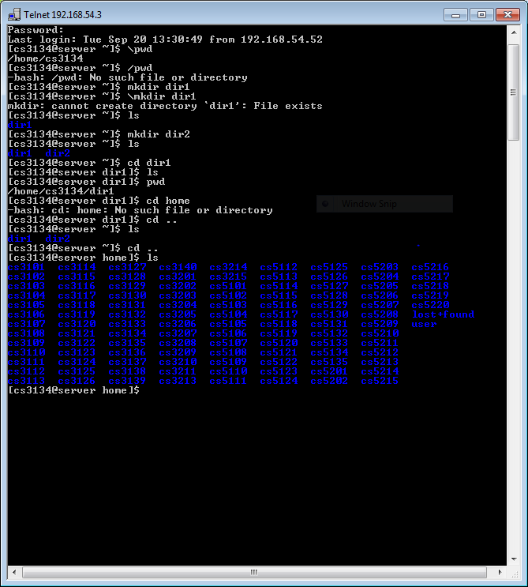

Press cd .. (again and again) and check the directory.

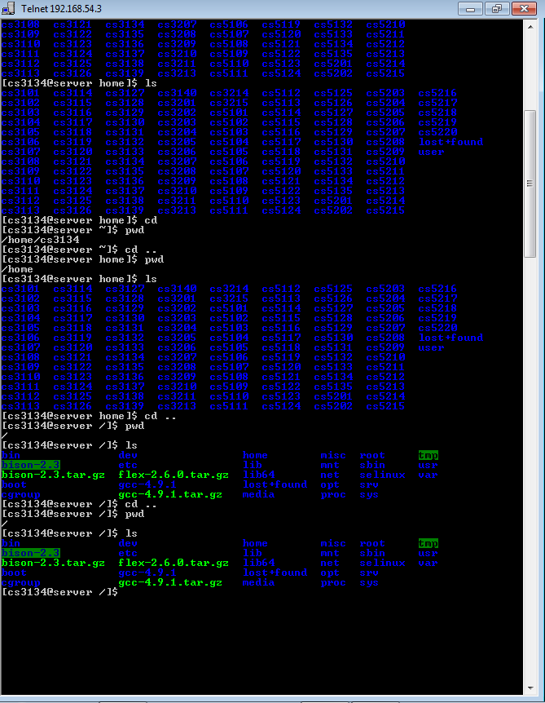

Also try : cd bin ; ls ;

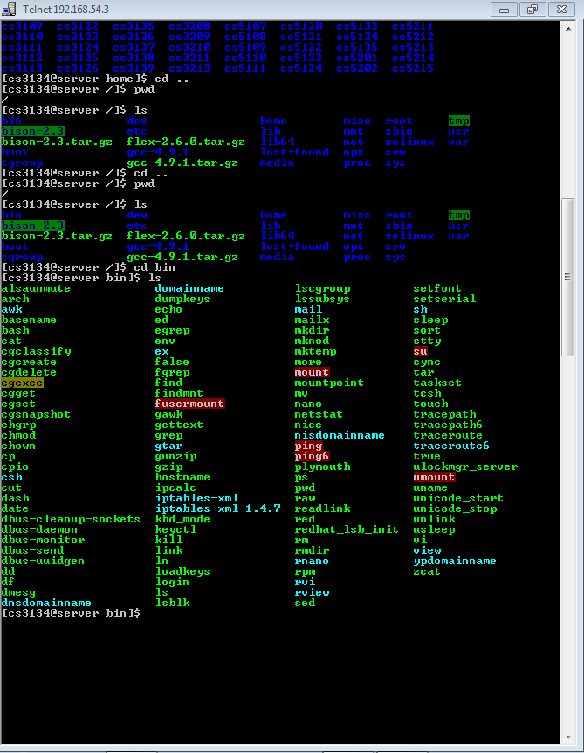

Also try, cd lib, etc.

$ cal : prints calendar

**$touch <f1> <f2> <f2>** : generates three blank files named f1, f2, f3

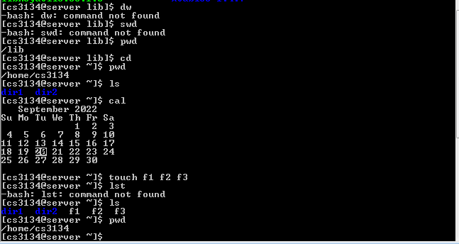

* Linux doesn’t allow the user to switch to other user’s directories. Also a user can alter the files in any location except its own home directory.

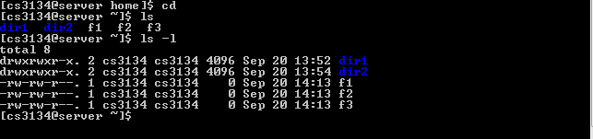

**$ls –l** : shows a seven column output (l stands for long list)

Explanation -> (

1st column begins with – or d where drwxrwxr-x means read write execute read write execute read execute, a row containing –rw-rw-r—means read write read write read ie. **The permissions given to the files or directory**

Rwx rwx r-x :row 1

111 111 101 :binary (1 for r/w/x)

7 7 5 :binary converted to decimal

2nd column shows the number of links . by default no of links for file is 1 and for the directory is 2.

3rd column shows the username of the login ID

4th column shows the group name . multiple users can be put in same group which grants permissions of edit, delete and execute to edit the files in the group to all the users

5th column shows the size of the directory/file

6th column shows the date and time when file was created

7th column shows the name of the directory or file

)

**Ques 3 : read, write, execute for a directory. Find the meaning.**

Ans : Read – means that user may see the contents of the directory

Write – means that user may create files in the directory

Execute – user may enter the directory (or make this a current directory) or traverse the directory

**Ques 4: for next lab**

**Rndir :** Removes the directory

**Ls -a :** enlist the whole list of current directory including hidden file

**ls -lh :** gives data in terms of file size in human readable format

**ls –lhs :** displays the file in descending order

**ls –p :** identify directory easily by marking the directories with slash (/) line sign

**ls –r :** used to print list in reverse order

**ls –lX :** groups the file with same extensions together in the list

**Cal :** displays a calendar of the specified year or month

**Rm :** provides a way to insert remarks (that will not be acted on) into a batch file

**Man :**  used to display user manual of any command that we can run on the terminal

**Cp :**  copying files from one location to another

**Ln :**  create links to files or directories

**Mv :**  move files and directory from one location to another

**Assignment : create a virtual machine on your windows system (15-20 days). Install a virtual machine ubuntu.**